THE INTERNATIONAL OCEAN STATION
POST ACTIVITY REPORT || OCT - DEC 2023

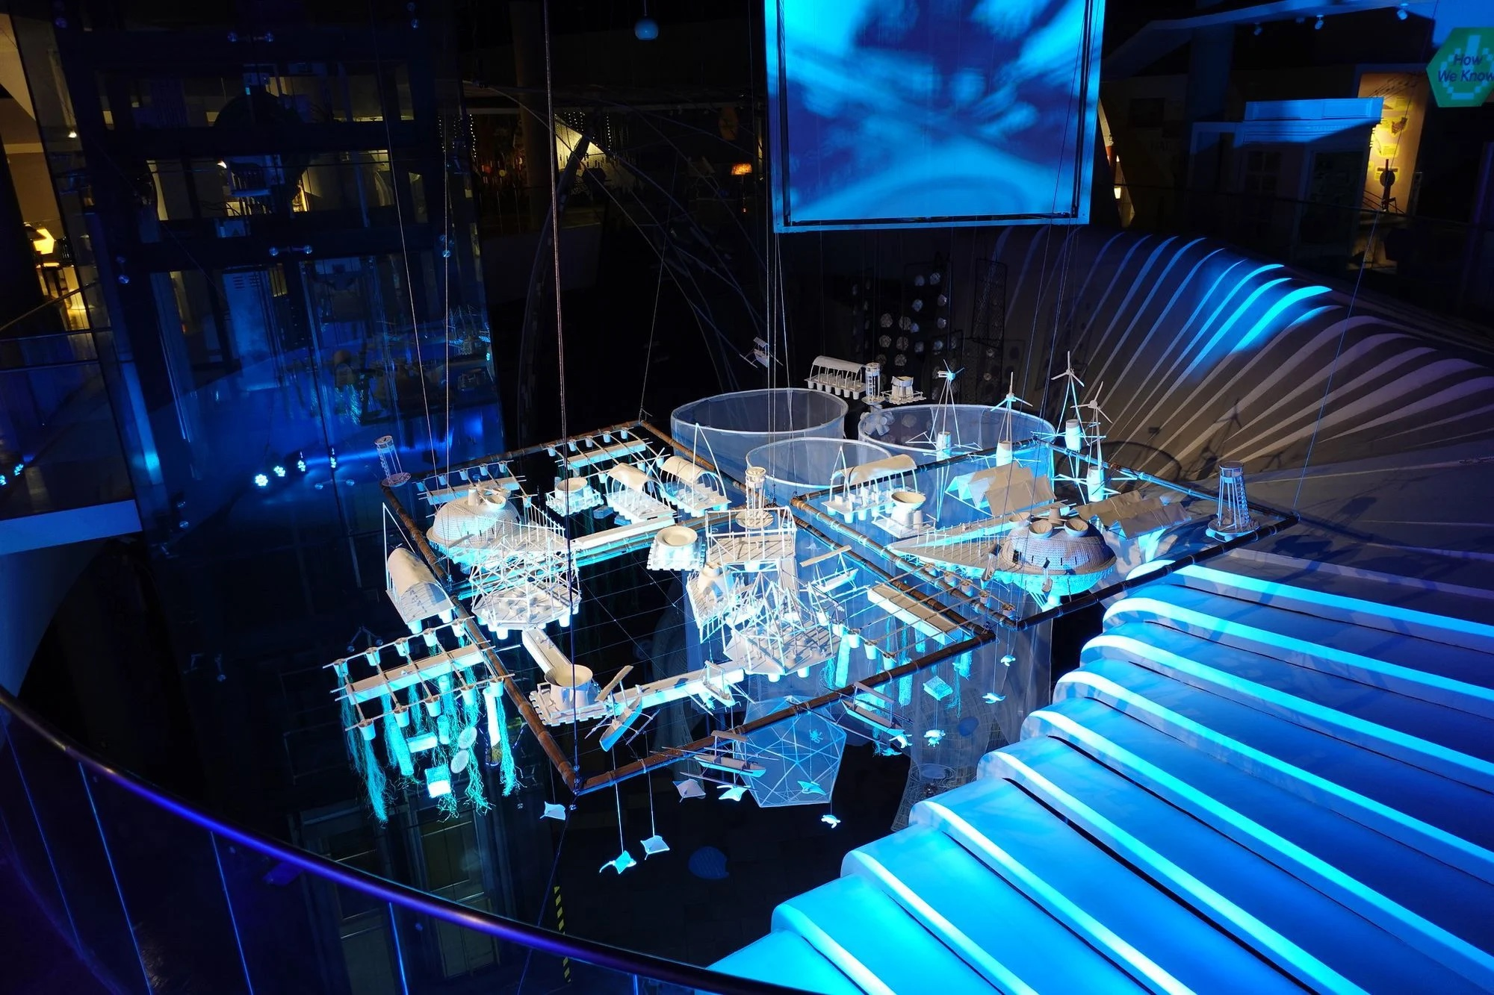

- BACKGROUND

Global warming disproportionately affects youth and Indigenous coastal communities in Asia. Yet, they are the groups that are generally excluded from the conversation, without a political voice, and undervalued as collaborators in the fields of science and art. How can young and Indigenous people take their future in their own hands, dream, design and transform their environment themselves?

The ocean is where all life started; it feeds billions of us, transports over 90% of our goods, and helps to regulate the climate. But human societies, especially those that have experienced urbanization, have become increasingly disconnected to the seas that surround us; to many, the ocean is mysterious at best, dangerous at worst. “International Ocean Stations” harks to the spirit of adventure that drove the international race to the moon, but subverts the elitist, technology-driven implications of space exploration. Like the ocean itself, the International Ocean Station is a playground, free for anyone to explore and enjoy. It starts with a dream, an open-ended conversation, an evocation of what could be. It’s designed by the youth and the Indigenous population, the fisherfolks, the elders, the visitors as it is an evolving instrumentation to explore and protect the sea, and our future. It may sound like the fantasy of a mad man, but it is a construction of the collective.

In the north of the Philippines, the ArtScientist in Residence Cesar Jung-Harada, is playing on the beach. Together with a group of newly found friends, they collect marine debris, and assemble intricate designs of a floating architectural model. As they build from reclaimed materials, they share stories from the past and the futures, their fears and their aspirations. The most ambitious endeavors might feel like myths or scifi, but that’s how every invention feels at first, between reality and magic, both art and science.

- SUMMARY:

The process of creating the Ocean Station was broken down into the following parts:

- Research phase: Early to mid October - community visits and story gathering (first stages done prior to Cesar’s arrival)
  - Date: Early to mid October
  - Details: The team met and discussed with multiple partner communities to discuss the idea of the IOS and to invite them to share their experiences with the ocean, and to brainstorm on ideas and thoughts about what the ocean station could be like.
  - Communities/Organizations partnered with:
    - CURMA
    - ALFARTS
    - Don Mariano Marcos Memorial State University - DMMMSU
    - La Union Surf Club
    - LINK
    - YES
    - DOERS

- Materials gathering - October 22-23
  - Date: October 22-23
  - Details: Prior to the workshop sessions, the team conducted a trash collecting session with the DOERS of Dalumpinas and other community members to gather waste material to be used for constructing the Ocean Station.
  - Attendees: Emerging Islands team, Cesar and family, DOERS of Dalumpinas

- Modelling, assembly, and prototype testing - October 23-28
  - Date: October 23-28, 2024 || 10am - 5pm
  - Details:
    - The team held daily workshop sessions with various communities in La Union to gather a diverse range of perspectives and stories to determine the structure for the Ocean Station.
    - Assembly of the Ocean Station was done as a team inspired by the models created by the participants of the workshop sessions
  - Attendees - Over 120 people over the course of six days
    - Surfers from San Juan
    - Indigenous People and Tangadan waterfalls tour guides from San Gabriel
    - Fisherfolk Community from Bacnotan
    - Eco-tourism rangers from Bauang Mangroves Eco park
    - Youth from all over La Union
    - Students from local schools/universities
    - Artists from all over the Philippines
    - Activists, professors, and scientists
  - Communications: Posters and instagram posts were made to encourage the community to attend. Samples found in link attached.
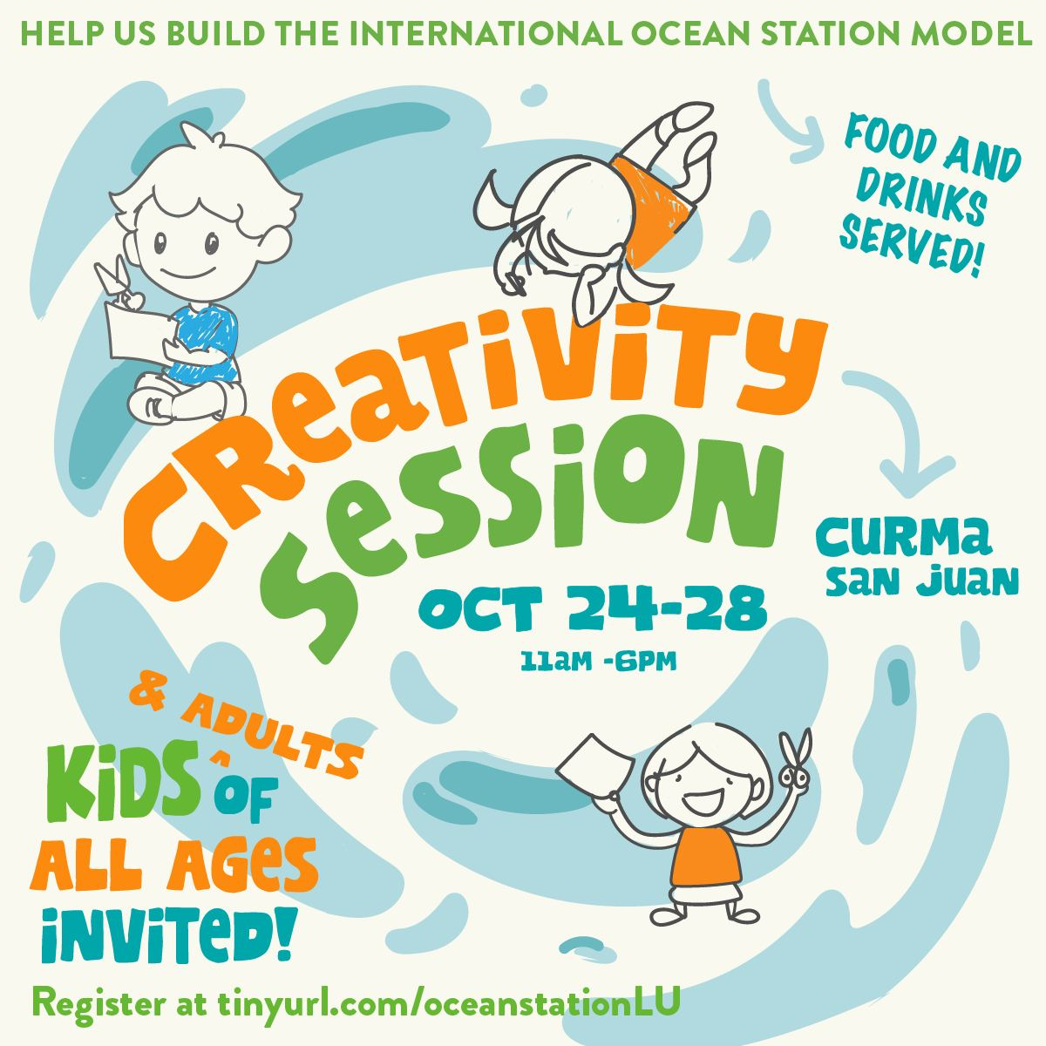

- Story production
  - Stories from the community dialogues, materials gathering and the construction of the station, were gathered by the team and collaborators, and finalized into a presentation for the community (and as exhibition material)

- Presentations of the Ocean Station
  - The Ocean Station was presented twice:
    - Launch 1
      - Date & venue: October 29, 2024|| CURMA turtle center, Ili Norte, San Juan, La Union
      - Details: This was a community event to celebrate the creation of the Ocean Station alongside the people who envisioned it
      - Attendees: Approx. 60+ people mostly workshop participants and community members
    - Launch 2
      - Date & venue: November 21, 2024, 7pm || The Mind Museum, BGC
      - Details: This event was the formal launch of the exhibit in the Mind Museum. Our partner organizations (DOERS and DMMMSU) were invited as panelists to share their experience during the building of the Ocean Station.
      - Attendees: 70+ people containing media, partner organizations, non-profit organizations, universities
      - Communications: link to invites and comms sent out in the links below:
        - Event invite: International Ocean Station_PRIVATE.png
        - Email invite
      - Event slides: 25703a93-bf17-4807-840f-0162d9fff860.pptx
      - Photos:
        - Launch photos
        - Images of the IOS
        - IOS panel soft copy bfe5c804-2700-4473-a6c2-b013216e877d.jpg

- KEY ACCOMPLISHMENTS

Below is a summary of milestones/key accomplishments achieved over the course of the project:

- Over 120 people contributed to dreaming up the International Ocean Station model, representing at least 10 different communities all over La Union, thus centering local stories in the Philippine and international conversation on the climate crisis. Over the course of six (6) days, the team successfully got over 120 people to attend the workshops, and contribute their ideas of what an international ocean station would be for them. The goal of IOS was to gather a diverse range of ideas, stories, and perspectives of what an International Ocean Station in La Union could look like, and to center the concerns and hopes of our local communities in the global climate change conversation. During our workshops, we successfully worked with a multitude of people from varying backgrounds that helped make sure the IOS was inclusive and grounded in local knowledge. In this way, the IOS models what a community-based response to the climate crisis should be like, and we hope it encourages others to explore similar approaches in their own localities.
- A beautiful artwork that provokes individual and social responses to the climate crisis, consisting of 15 prototype models for the International Ocean Station, co-created by Cesar and our La Union community. The IOS exhibit at the Mind Museum is a feat of collaborative design shaped by local stories. The workshop participants created a total of 50 models, from which Cesar developed 15 prototype units that would comprise the IOS. These models, the stories that shaped them, and the story of how they were designed from start to finish, are art objects in themselves, as much as they also offer a public platform and gathering space in which to discuss the climate crisis, and center local communities in such dialogues.
- The multiplication and diversification of inter-community discussions and creative collaboration around the climate crisis. The workshops and the exhibit itself also succeeded at expanding and multiplying the spaces and opportunities for discussions around the climate crisis. It’s important to have more art-science interventions like this outside of city capitals, and directly within coastal and frontline communities themselves. It’s also important to create more visibility and provocation around the climate crisis in the city, which the permanent exhibit at the Mind Museum accomplishes, successfully bringing the story of the IOS to the thousands of students from diverse backgrounds that visit the institution weekly.
- A format for collaborative storytelling, community-based design, and art-science interventions.
The workshop that Cesar Jung Harada, Emerging Islands, and our community partners co-developed offers an iterative format for fostering co-creative community responses to the climate crisis. It can also be applied to other environmental issues such as plastic pollution or environmental resource management.

- INSIGHTS FROM PARTICIPANTS

  - John Rick, college student in La Union:
    - Forced to fend for himself at a young age, he made friends with fishermen who taught him how to fish. Recalling difficult memories with a heavy heart, John Rick yearns for the International Ocean Station to feature a rest stop for fishermen going on long fishing voyages, like he once did. He now studies Public Administration in college, and wants to someday, help local communities secure a future.
  - Ate Josie, a mangrove steward from Bauang, La Union:
    - Her community has been waiting for the government to reopen their mangrove eco-park for more than two years. They added a floating restaurant to the International Ocean Station, dreaming of a time when they can finally earn a livelihood from the ecological work they are already doing. They welcome the idea of tourists, but want to be able to thrive from what their mangrove home can offer.
  - Kuya Jessie, fisherman turned patroller for our partner, turtle conservation organisation CURMA
    - He taught us that sea turtles encourage the growth of seagrass, which is where the fish like to lay their eggs. He learned how to look for turtle nests not from CURMA, but from his father, who knew when to go on patrol just by looking at the moon. He also told us that the intensifying typhoons and the growing tourism in La Union are impacting the natural cycles he grow up knowing intimately.

- RECOMMENDATIONS/INSIGHTS

  - Structuring the workshop in a simple standardized format made it easier to work with more communities
  - More strategic manpower division - assistance & resources, more time
  - NEXT STEPS:
    - Processing where else this could be done - dream building for a real IOS
    - Translating the materials for further educational use
    - Brainstorm future applications and opportunities for the co-creative workshop model that we developed

- ANNEX A

- Budget breakdown - Actual International Ocean Station budget
- Link to latest draft of “the making of” video of the IOS - 2024_1_3 EI_7.mp4
- Links to albums of photos/videos
  - https://www.flickr.com/photos/worldworldworld/albums/72177720311270383/
  - IOS Photos by Hannah
  - https://photos.app.goo.gl/QunVQpo1BdmwsJc69

"Department of Economic and Social Affairs. Indigenous Peoples. Climate Change." Retrieved Jul 2023. https://www.un.org/development/desa/indigenouspeoples/climate-change.html
"Asia Is Home to 99 of the World’s 100 Cities Facing the Greatest Environmental Challenges", CIARA NUGENT, TImes. May 13, 2021 9:00 AM EDT. https://time.com/6048106/asia-environment-risk-cities/

